Mixed-Shape Decomposition

Definition
# Source: AI Source: Provided by: [Data Path: Persons Table -> ID Column: 1, Name_En Column: Motasem Essam] -> From: [ChatGPT] on [7/25/2026]
Mixed-Shape Decomposition is a type of geometric figure decomposition in which a complex geometric figure is divided into two or more simpler components belonging to different geometric shape types.
The components may include rectangles, triangles, circles, semicircles, trapezoids, circular sectors, and other shapes. The purpose is to simplify calculations, analyze the figure's structure, or determine its area and perimeter.
Simple definition: Mixed-shape decomposition is dividing a complex figure into simpler pieces of different geometric shapes.
Examples include:
- Dividing a house-shaped figure into a rectangle and a triangle.
- Dividing a composite figure into a rectangle and a semicircle.
- Separating a figure into triangles, rectangles, and circular sectors.
- Calculating the area of a region by subtracting a circular hole from a rectangle.

Main Classification
# Source: AI Source: Provided by: [Data Path: Persons Table -> ID Column: 1, Name_En Column: Motasem Essam] -> From: [ChatGPT] on [7/25/2026]
The following is a practical, descriptive classification, not a universally standardized mathematical taxonomy. The categories may overlap.

1. Polygon–Polygon Mixed-Shape Decomposition
# Source: AI Source: Provided by: [Data Path: Persons Table -> ID Column: 1, Name_En Column: Motasem Essam] -> From: [ChatGPT] on [7/25/2026]
A complex polygon is divided into different types of polygons.
Example: A house-shaped region separated into a rectangle and a triangle.
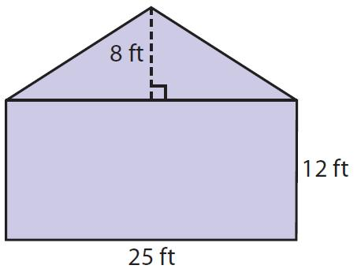
Detailed Explanation and Examples
Definition: A polygonal figure is divided into simpler polygons of different types, such as rectangles, triangles, and trapezoids.
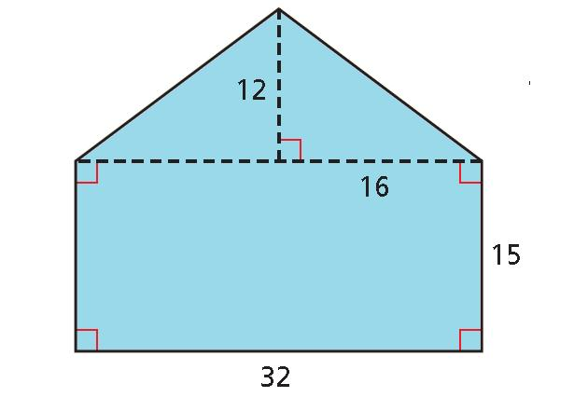
Example: A house-shaped region consists of a rectangle measuring $8×5$ units and a triangular roof with base $8$ units and height $3$ units.
Rectangle area:
$$A_{1}=8\left(5\right)=40$$
Triangle area:
$$A_{2}=\frac{12}{\left(8\right)}\left(3\right)=12$$
Total area:
$$A_{\text{total}}=A_{1}+A_{2}$$
$$\boxed{A_{\text{total}}=52}$$
The two regions have non-overlapping interiors, so their areas can be added directly.

2. Polygon–Circular Mixed-Shape Decomposition
# Source: AI Source: Provided by: [Data Path: Persons Table -> ID Column: 1, Name_En Column: Motasem Essam] -> From: [ChatGPT] on [7/25/2026]
A figure is divided into a polygon and a circular part.
Example: A rectangle joined to a semicircle.
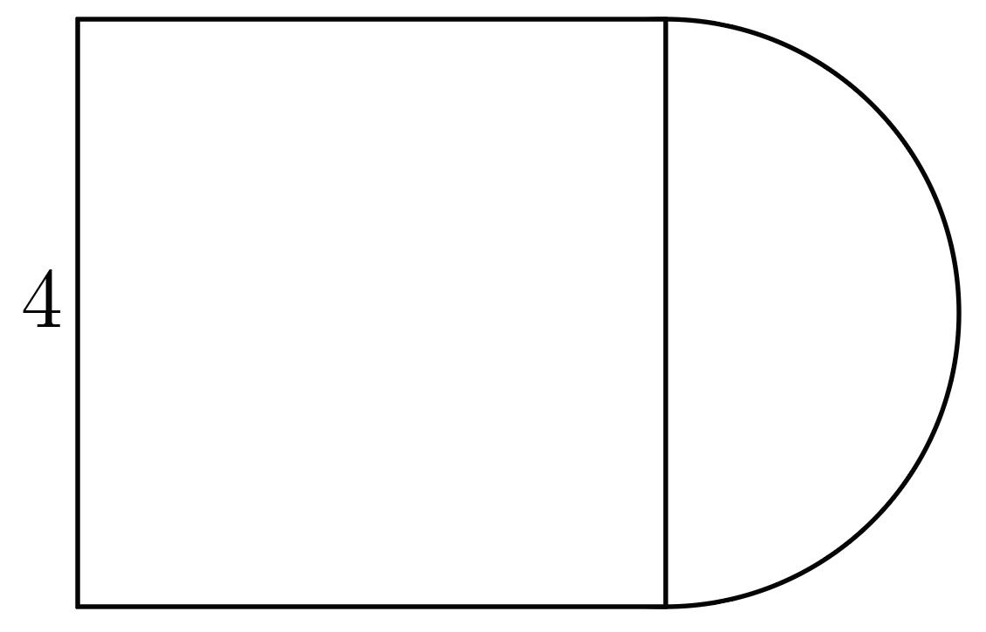
Detailed Explanation and Examples
Definition: A composite figure is divided into a polygon and a circular component, such as a semicircle, quarter-circle, or circular sector.
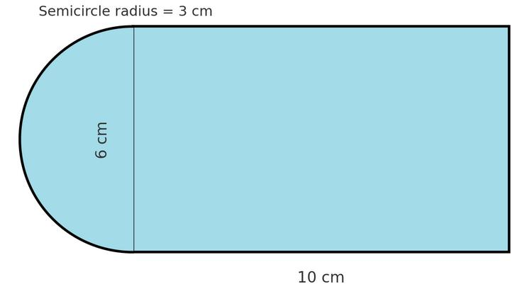
Example: A rectangle measuring $8×6$ units is joined to a semicircle of radius $3$ units along one short side.
Rectangle area:
$$A_{1}=8\left(6\right)=48$$
Semicircle area:
$$A_{2}=\frac{12}{π}{\left(3\right)}^{2}=\frac{9π}{2}$$
Total area:
$$\boxed{A_{\text{total}}=48+\frac{9π}{2}}$$
The approximate area is $62.14$ square units.

3. Multiple-Shape Decomposition
# Source: AI Source: Provided by: [Data Path: Persons Table -> ID Column: 1, Name_En Column: Motasem Essam] -> From: [ChatGPT] on [7/25/2026]
A complex region is divided into three or more different shape types.
Example: A rectangle, a triangle, and a quarter-circle forming one figure.
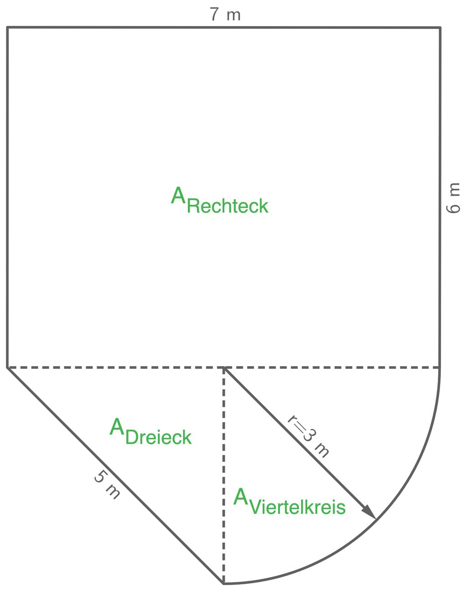
Detailed Explanation and Examples
Definition: A complex figure is divided into three or more simpler components that may belong to different geometric shape types.
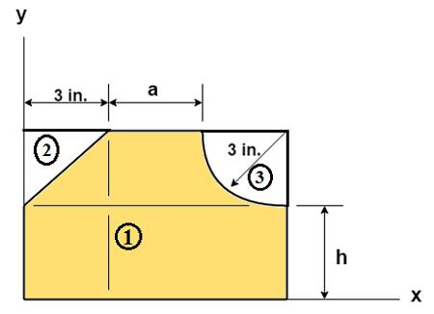
Example: A composite region consists of:
- A rectangle measuring $10×4$ units.
- A triangle with base $4$ units and height $3$ units.
- A semicircle of radius $2$ units.
Assuming these regions have non-overlapping interiors:
Rectangle:
$$A_{1}=10\left(4\right)=40$$
Triangle:
$$A_{2}=\frac{12}{\left(4\right)}\left(3\right)=6$$
Semicircle:
$$A_{3}=\frac{12}{π}{\left(2\right)}^{2}=2π$$
Total area:
$$\boxed{A_{\text{total}}=46+2π}$$
The approximate area is $52.28$ square units.

4. Subtractive Mixed-Shape Decomposition
# Source: AI Source: Provided by: [Data Path: Persons Table -> ID Column: 1, Name_En Column: Motasem Essam] -> From: [ChatGPT] on [7/25/2026]
A figure is analyzed as a larger shape with a smaller shape removed.
Example: A rectangular plate with a circular hole.
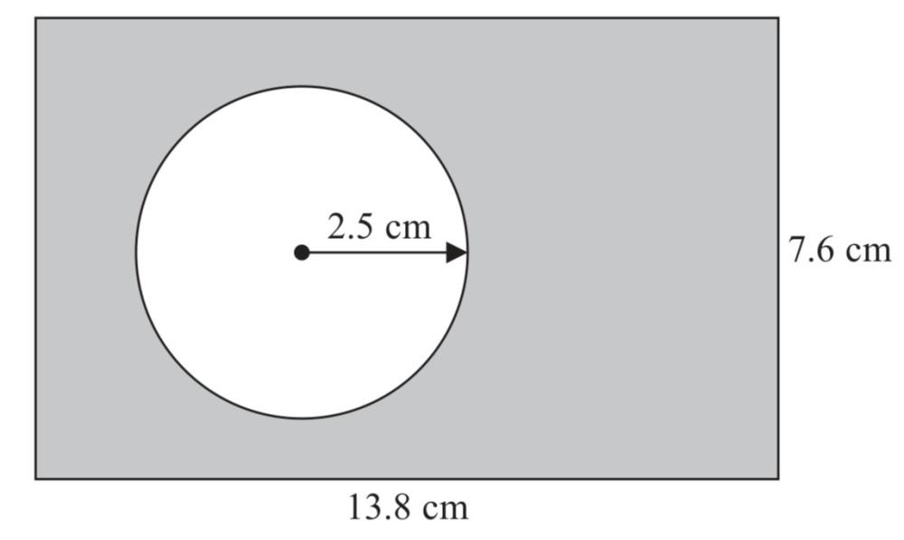
Detailed Explanation and Examples
Definition: A figure is treated as a larger geometric region from which a smaller region is removed. This method is particularly useful when the removed part has a different shape from the original figure.
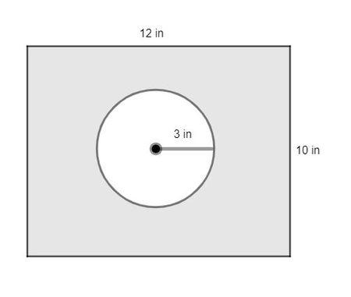
Example: A rectangular plate measures $12×8$ units and contains a circular hole of radius $2$ units.
Rectangle area:
$$A_{\text{rectangle}}=12\left(8\right)=96$$
Circular hole area:
$$A_{\text{circle}}=π{\left(2\right)}^{2}=4π$$
Remaining area:
$$A_{\text{remaining}}=A_{\text{rectangle}}-A_{\text{circle}}$$
$$\boxed{A_{\text{remaining}}=96-4π}$$
The approximate remaining area is $83.43$ square units.
Important: The circular hole is not part of the remaining material, so its area is subtracted rather than added.

5. Irregular-Figure Mixed-Shape Decomposition
# Source: AI Source: Provided by: [Data Path: Persons Table -> ID Column: 1, Name_En Column: Motasem Essam] -> From: [ChatGPT] on [7/25/2026]
An irregular figure is partitioned into convenient simpler shapes.
Example: An irregular region separated into a triangle, a trapezoid, and a rectangle.
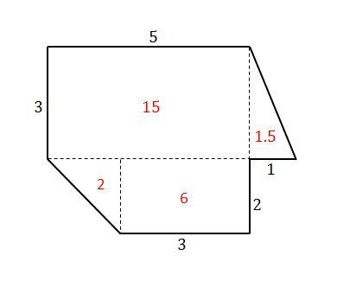
Detailed Explanation and Examples
Definition: An irregular geometric region is divided into convenient components of different shapes so that each component can be measured separately.
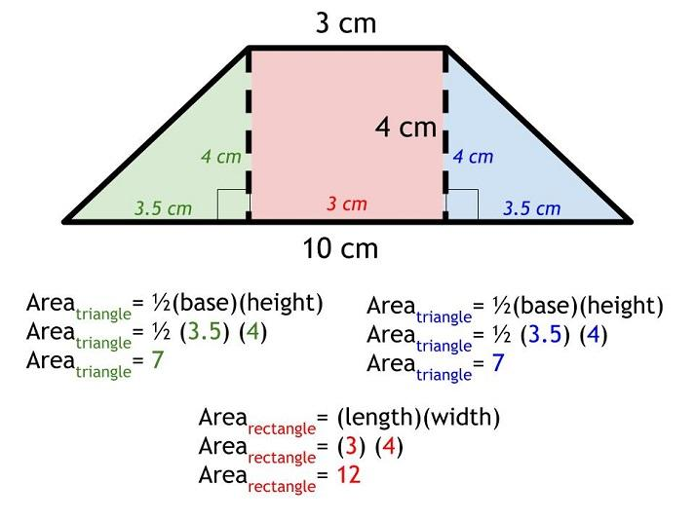
Example: An irregular region is divided into:
- A triangle with base $4$ and height $5$.
- A rectangle measuring $6×5$.
- A trapezoid with parallel sides $4$ and $6$, and height $5$.
Triangle area:
$$A_{1}=\frac{12}{\left(4\right)}\left(5\right)=10$$
Rectangle area:
$$A_{2}=6\left(5\right)=30$$
Trapezoid area:
$$A_{3}=\frac{12}{\left(4+6\right)}\left(5\right)=25$$
Total area:
$$\boxed{A_{\text{total}}=10+30+25=65}$$
This calculation is valid when the components fit the original region exactly without gaps or overlapping interiors.

6. Boundary-Based Mixed-Shape Decomposition
# Source: AI Source: Provided by: [Data Path: Persons Table -> ID Column: 1, Name_En Column: Motasem Essam] -> From: [ChatGPT] on [7/25/2026]
A figure is separated according to changes in its straight and curved boundaries.
Example: A figure containing both straight edges and a semicircular arc, decomposed into polygonal and circular parts.
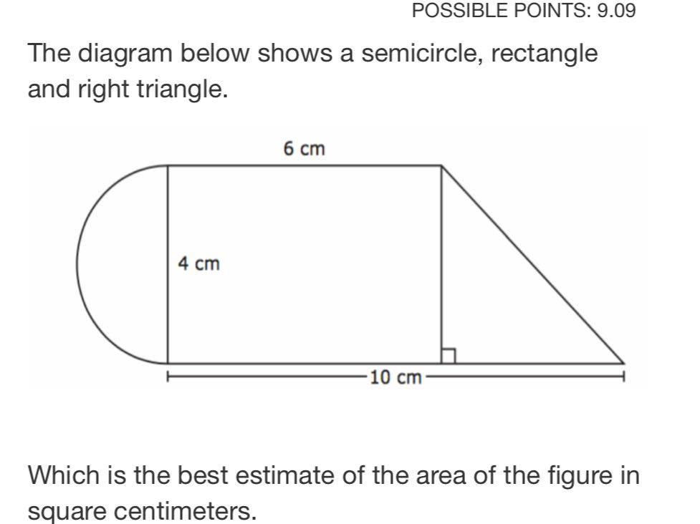
Detailed Explanation and Examples
Definition: A figure containing both straight and curved boundaries is separated into simpler polygonal and curved components.
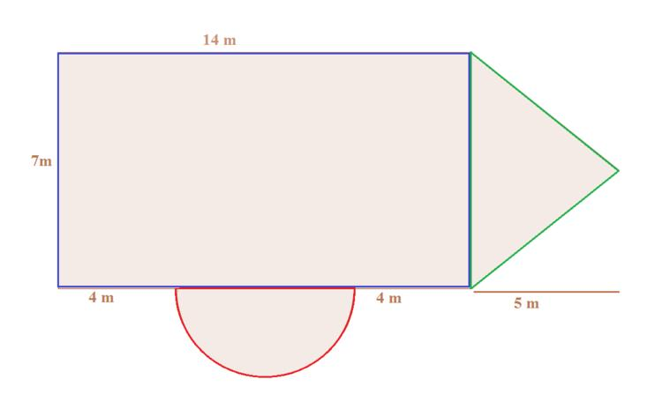
Example: A region consists of a rectangle measuring $8×4$ units and a semicircle of radius $2$ units attached along a short side.
Rectangle area:
$$A_{1}=8\left(4\right)=32$$
Semicircle area:
$$A_{2}=\frac{12}{π}{\left(2\right)}^{2}=2π$$
Total area:
$$\boxed{A_{\text{total}}=32+2π}$$
The main idea is to identify where the straight-edged component ends and the curved component begins.

Important Formulas
# Source: AI Source: Provided by: [Data Path: Persons Table -> ID Column: 1, Name_En Column: Motasem Essam] -> From: [ChatGPT] on [7/25/2026]
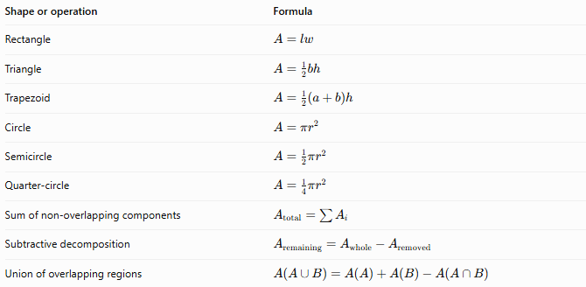
Shape or operation | Formula
Rectangle | $$A=lw$$
Triangle | $$A=\frac{1}{2}bh$$
Trapezoid | $$A=\frac{1}{2}\left(a+b\right)h$$
Circle | $$A=πr^{2}$$
Semicircle | $$A=\frac{1}{2}πr^{2}$$
Quarter-circle | $$A=\frac{1}{4}πr^{2}$$
Sum of non-overlapping components | $$A_{\text{total}}=\sum{A_{i}}$$
Subtractive decomposition | $$A_{\text{remaining}}=A_{\text{whole}}-A_{\text{removed}}$$
Union of overlapping regions | $$A\left(A∪B\right)=A\left(A\right)+A\left(B\right)-A\left(A∩B\right)$$

Mixed-Shape Decomposition vs. Related Concepts
# Source: AI Source: Provided by: [Data Path: Persons Table -> ID Column: 1, Name_En Column: Motasem Essam] -> From: [ChatGPT] on [7/25/2026]
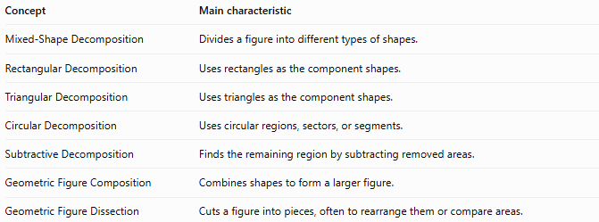
Concept | Main characteristic
Mixed-Shape Decomposition | Divides a figure into different types of shapes.
Rectangular Decomposition | Uses rectangles as the component shapes.
Triangular Decomposition | Uses triangles as the component shapes.
Circular Decomposition | Uses circular regions, sectors, or segments.
Subtractive Decomposition | Finds the remaining region by subtracting removed areas.
Geometric Figure Composition | Combines shapes to form a larger figure.
Geometric Figure Dissection | Cuts a figure into pieces, often to rearrange them or compare areas.

Classification Summary
# Source: AI Source: Provided by: [Data Path: Persons Table -> ID Column: 1, Name_En Column: Motasem Essam] -> From: [ChatGPT] on [7/25/2026]
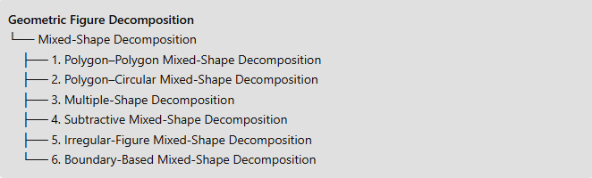
Geometric Figure Decomposition
└── Mixed-Shape Decomposition
├── 1. Polygon–Polygon Mixed-Shape Decomposition
├── 2. Polygon–Circular Mixed-Shape Decomposition
├── 3. Multiple-Shape Decomposition
├── 4. Subtractive Mixed-Shape Decomposition
├── 5. Irregular-Figure Mixed-Shape Decomposition
└── 6. Boundary-Based Mixed-Shape Decomposition

Key Points
# Source: AI Source: Provided by: [Data Path: Persons Table -> ID Column: 1, Name_En Column: Motasem Essam] -> From: [ChatGPT] on [7/25/2026]
- Mixed-shape decomposition uses different geometric shape types as components.
- It is useful for calculating the area of complex or irregular figures.
- Areas can be added when components cover the figure without gaps or overlapping interiors.
- Removed regions must be subtracted.
- Overlapping regions require correcting for the intersection to avoid double-counting.
- The classification is practical and descriptive; its categories can overlap.

Conclusion
# Source: AI Source: Provided by: [Data Path: Persons Table -> ID Column: 1, Name_En Column: Motasem Essam] -> From: [ChatGPT] on [7/25/2026]
Mixed-Shape Decomposition simplifies complex geometric figures by dividing them into familiar shapes whose properties and formulas are easier to use. The most important step is selecting a valid decomposition that covers the original region exactly, then calculating each component's area and combining the results appropriately.

